WILSON 2019 WINTER
DANCE TEAM CLINIC
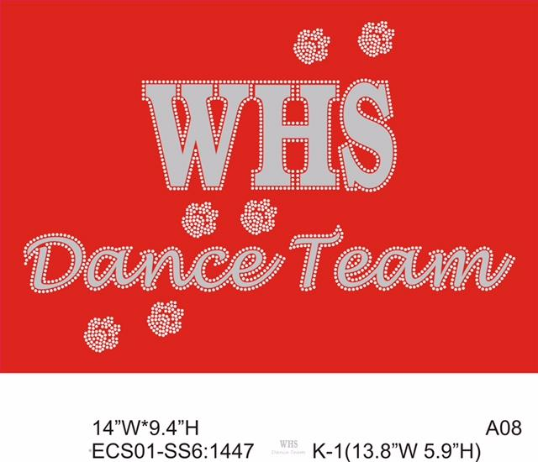
This day clinic is available to the young Bulldogs of the area to learn and develop Dance Skills. The coaching staff would love to have the opportunity to work with your child to offer training and a great performance opportunity/experience. We strive to develop each dancer’s confidence through age appropriate choreography and experienced based groups. The clinic will culminate in an additional and optional in-game performance with the WHS Dance Team at halftime of the Boys Varsity Basketball Game on Saturday, December 7th!

STAFF: Wilson High School Co-Directors Jen Caputo and Erica Hassler and members of the 2019-2020 WHS Dance Team
FOR: Any young Bulldog (Boys and Girls) in Grades K-9 in Fall of 2019. *Campers will be grouped by ability: Beginners, Intermediate, & Advanced
DATE: Saturday, December 7,, 2019
WHERE: Yocum Institute (3000 Penn Avenue, West Lawn)
TIME: Clinic: 12-2pm @ Yocum Institute. Game: 7pm (arrival details TBD)
COST: $50
OTHER INFO: Campers will be given a performance t-shirt to wear for the clinic. They should wear the t-shirt with any full length black leggings. Any comfortable attire can be worn to the clinic. *Parents are invited to return to the clinic at 1:45pm to watch/video the practice performance/choreography.

*All Clinic Dancers are invited to perform with the WHS Dance Team at halftime of the Boys Varsity Basketball Game on Saturday, December 7th. All performers should wear their Clinic t-shirt with black leggings for the performance. Pre-Performance practice will take place from 7-7:30pm during the game.

2019 WILSON SPORTS
DANCE TEAM CLINIC BROCHURE

Wilson School District is offering, to resident, taxpaying families of the Wilson School District, a dance clinic designed to give you an opportunity to learn and improve skills, enhance techniques, and enjoy a live performance experience. Dance Team Directors Jen Caputo and Erica Hassler will be directing this clinic with the WHS Dance Team.

RULES AND REGULATIONS
All individuals enrolled are required to comply with the rules and regulations of the Wilson School District. Any violation of these rules will result in dismissal from the camp/clinic without a refund.

TEE SHIRTS
A performance tee shirt will be given to each camper as part of the clinic fee.
All performers should where the Clinic Tee with Black Leggings to the In-Game performance.

TRANSPORTATION
Transportation to and from the clinic/game will be each student’s responsibility.

CLINIC SIZES
Each clinic has a size limit (min. as well as max.). Registration for all clinics is first come – first serve. Please be advised, if you register a child for a clinic that is filled you will be notified and placed on a waiting list.

REGISTRATION:
All registration forms must be filled out online at www.wilsonsd.org/communityrecreation! Accepted forms of payment include: online (credit or debit will incur a convenience charge), check, or money order.
Contact: Wilson School District
Athletic Office
2601 Grandview Blvd.
West Lawn, PA 19609
(610) 670-0180 ext.1141
Make checks/money orders payable to the: WILSON SCHOOL DISTRICT

Please remember that without payment a spot will not be saved for the camper. Should a cancellation of the clinic occur, a refund minus $10 processing fee may be requested. You may also be notified to inform you that a camp/clinic has been filled. It is imperative that you complete the form in its entirety so we have the proper information to contact you. REGISTRATION CLOSES MONDAY DECEMBER 2,

