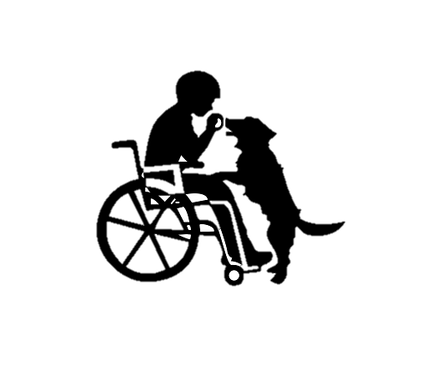
i CAN dINE in the DARK

Join us at our 2nd annual dinner under blindfold, sponsored by Whitfield Student Council
All proceeds from the event will go to Canines for Disabled Kids
DATE: Saturday April 21, 2018
TIME: ONE seating at 6:00 pm
WHERE: Wilson High School Upper House Cafeteria
PRICE: $20 for adults $7 for students
Tickets must be paid for prior to the event. Limited tickets will be sold at the door.

Tickets may be purchased by visiting the Whitfield Elementary Webpage at www.wilsonsd.org
or by contacting Anna Ackley at ackann@wilsonsd.org.
Checks should be made payable to “Whitfield Student Council”
And mailed to: Whitfield Elementary
2700 Van Reed Road, West Lawn PA, 19609
Paypal available upon request
Questions should be directed to Anna Ackley at ackann@share.wilsonsd.org

Please RSVP by April 13th

