Camp Cadet is a police-oriented summer camp for youth ages 12 through 15 from Berks, Lebanon, and Schuylkill Counties.

Why police-oriented?

The purpose of the camp is to provide youth with a positive growth experience within the framework of a “mini” police academy structure. The Camp Cadet philosophy is embodied in the motto: Growth Through Discipline – Achievement Through Teamwork – Pride Through Respect.

Camp Cadet stresses instruction in law enforcement topics, safety, and physical training. Other activities include fishing, swimming, marksmanship, horseback riding and softball.

All camp activities are supervised by a counseling staff to State Police and local police officers. Counselors reside at the camp with the cadets.

How are Cadets selected?

Every effort is made to accommodate all interested applicants who have not previously attended the camp. If applicants number more than the available camp spaces, a random drawing of applicants will be conducted on a county population basis. Requirements for attendance at the Camp Cadet Program include residency in Berks, Lebanon, and Schuylkill Counties and a desire on the part of the candidate to complete the camp.

What does Camp Cadet cost?

Camp Cadet has a $140.00 non-refundable registration fee, payable when accepted for camp.
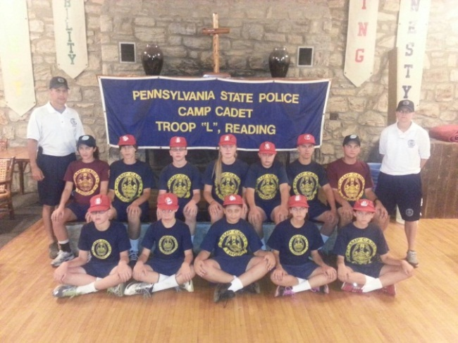

What is Camp Cadet Like?

Each day begins with reveille and ends with retreat formation. Cadets awaken early and prepare their quarters for inspection.

Cadets participate in morning physical training and march in platoon formations to their classes and activities under the watchful eyes of police instructors.
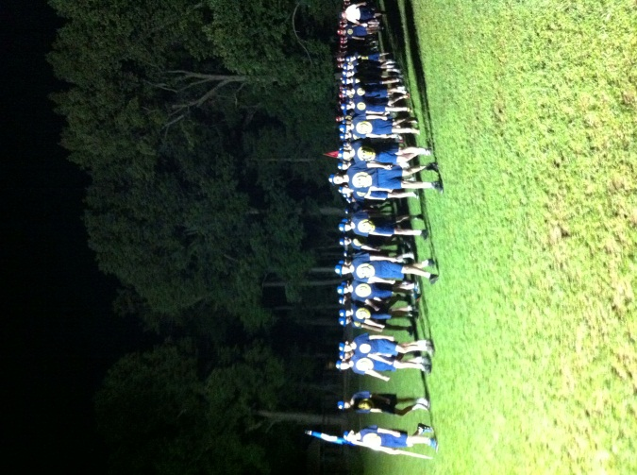
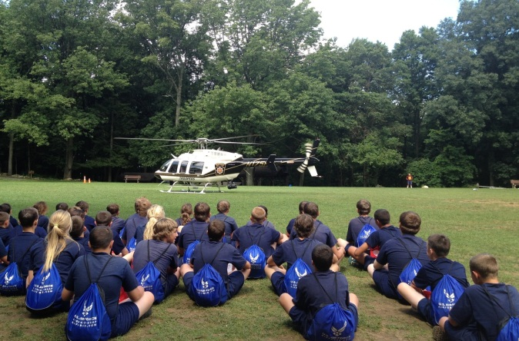

How does a youth apply?

It’s easy! Complete the application form on the back of this brochure and return before the deadline. Additional copies are available at any State Police Station and most municipal police departments in Berks, Lebanon, and Schuylkill Counties.

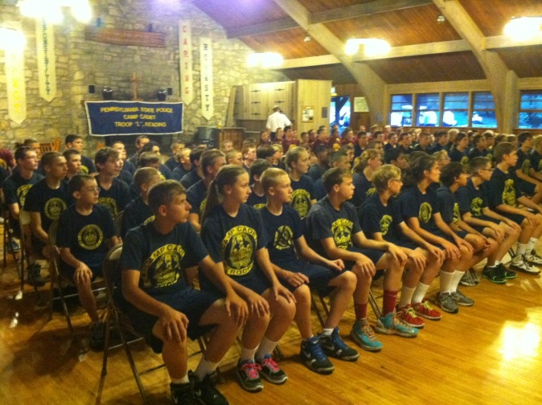

I am interested in attending Camp Cadet and would like to be interviewed for acceptance. I understand that I must be between 12 and including 15 years-of-age on the date camp begins, and be a resident of Berks, Lebanon or Schuylkill Counties.

Application and $10.00 application fee must be returned no later than May 31, 2022, to:

Camp Cadet
P.O. Box 6845
Wyomissing, PA 19610-0845

DO NOT SEND MONEY WITH THIS APPLICATION.

A non-refundable fee of $140.00 will be collected at the time of acceptance into camp.

Name:
Mailing Address:
Residence Location:
Phone:
Age: Sex:
Date of Birth:
Parents Name(s):
Parent’s Address:
Phone:
Previous Year(s) applied:
School:

Do they like it?
Cadets write:

“This has been the most rewarding experience of my life so far.”

“I had a great time at camp. Thank you for letting me get into Camp Cadet.”

“I had the time of my life this summer. I learned things about myself and my capabilities that I never knew I had. Thank you for giving me such a memorable week at camp.”

Parent’s write:

“When we first found out about Camp Cadet we were desperate parents trying to find a positive experience for our son. Camp Cadet was that experience, thank you.”

“He has not stopped talking about camp since we picked him up, and what a great change we see in him. Thank you.”

“Our child has benefitted tremendously from this one week and we were amazed to see the difference it has made. We cannot thank you enough for the dedication and willingness to help and serve your people this way. The graduation ceremony was certainly proof that your labor of love and concern for these young lives paid off in many ways.”

FIND US AT:

Facebook – Camp Cadet Troop L Alumni

On the Web – www.campcadettroopL.com

PA STATE POLICE
TROOP L
CAMP CADET
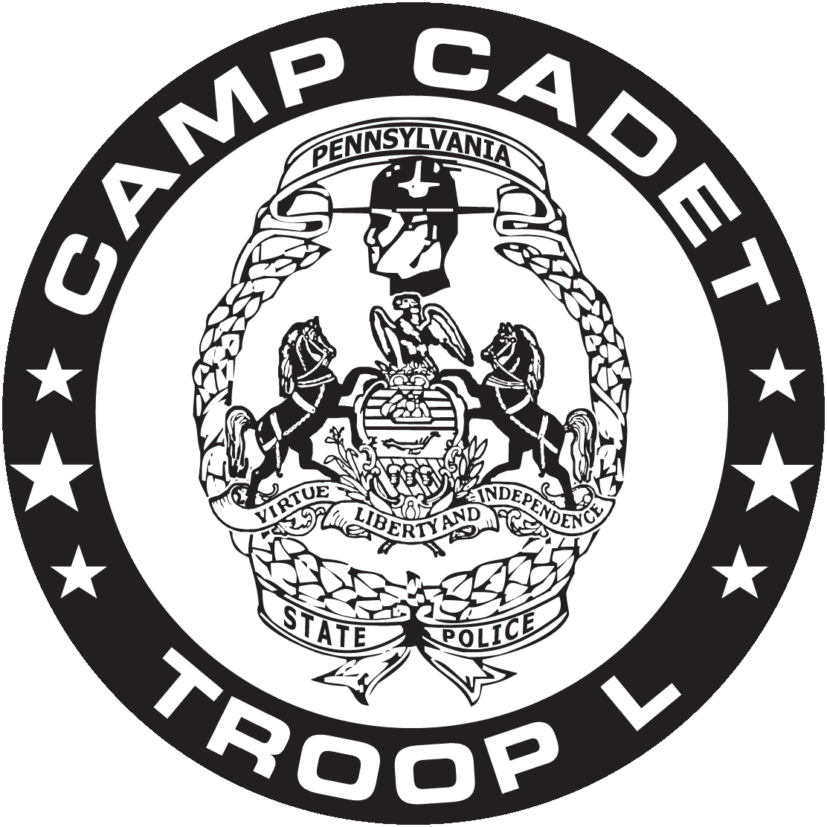
AUGUST 14, 2022 – AUGUST 20, 2022
A Youth Development Program
conducted by Troop L
of the Pennsylvania State Police and
Municipal Police from Berks, Lebanon, and Schuylkill Counties

