New Whitfield Arrival and Dismissal 2017-2018
3-5
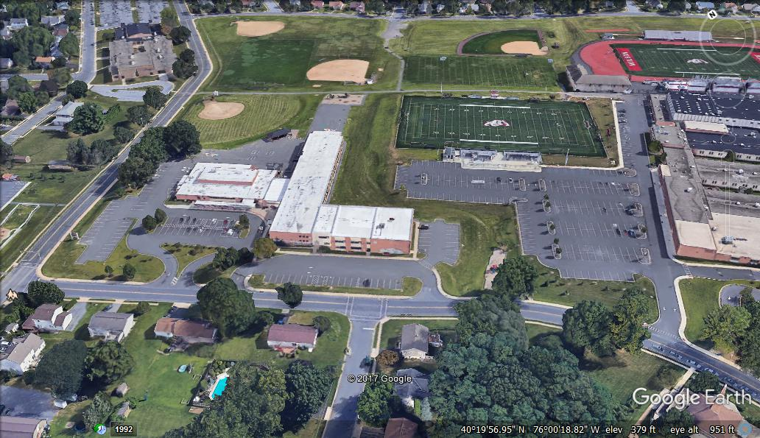
Crossing Guard
- Traffic Patterns - Parking for Pick Up at Lower House Lot - Breakfast Only Entrance - Staff Parking
- Dismissal Locations - No Access (Bus Only) - Student Entrances (depending on drop-off location)
- Visitor Parking - Student Walking Paths - Paved walking path with steps in the middle
St Albans Church lot
Walkway/Steps
Whitfield E.S.
1
Lower House
Lot
Van Reed Road
Dwight Street
One Stop, Drop #2
One Stop, Drop #1
2
K-2

Walkway/Steps #2

We listened to your concerns about safety and convenience. The “Walkway/Steps,” highlighted in yellow on the map, will help with morning arrival and afternoon dismissal. The Walkway/ step area is a walking path with steps in the middle.

Morning Arrival - Vehicles coming down from Dwight Street are to use the arrival pattern that goes through the Lower House Lot, labeled “One Stop, Drop #2.” Upon drop off, students will stay on the walking path and use the new Paved Area to enter the door closest to the gym at the back of the building (smiley face #2).

Vehicles coming up from Van Reed Road are to use the arrival pattern that loops in front of Whitfield labeled “One Stop, Drop #1.” Upon drop off, students will stay on the walking path and enter through the Pond Door (smiley face #1).
Afternoon Dismissal - Families can park in the Lower House Lot and walk down to pick up their student(s) around the back of the building, using the new Walkway/Steps Area.

Alternate Option: St. Albans Church has agreed to allow parents to park in their lot and students can use the path indicated above to walk to the crossing guard located at Van Reed Road. Please be mindful that St. Albans Preschool is in operation during our drop off/ pick up times, so use caution when entering and exiting their parking lot.

